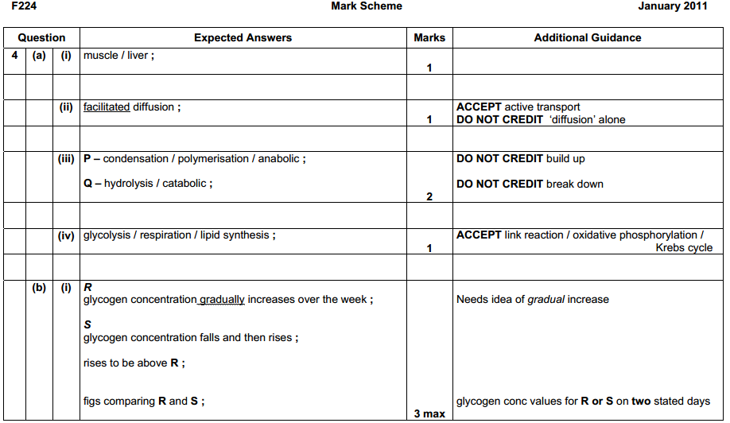

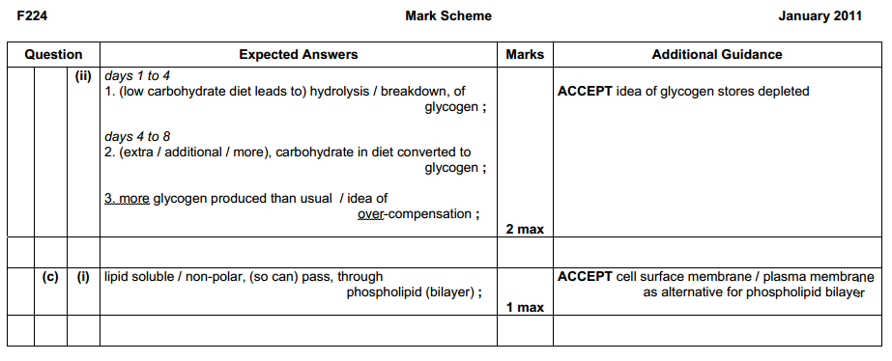

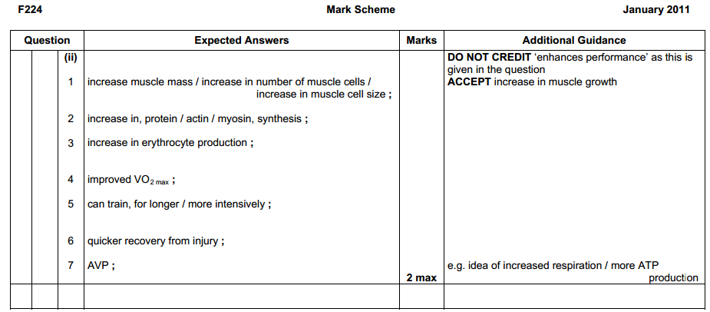

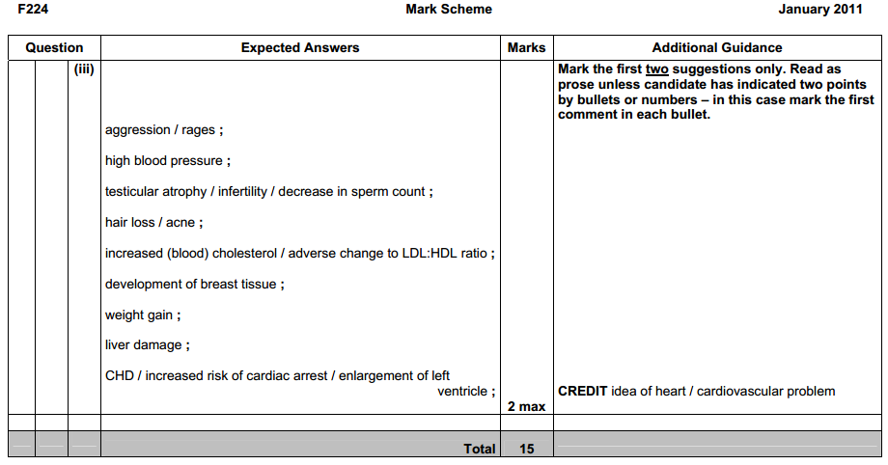

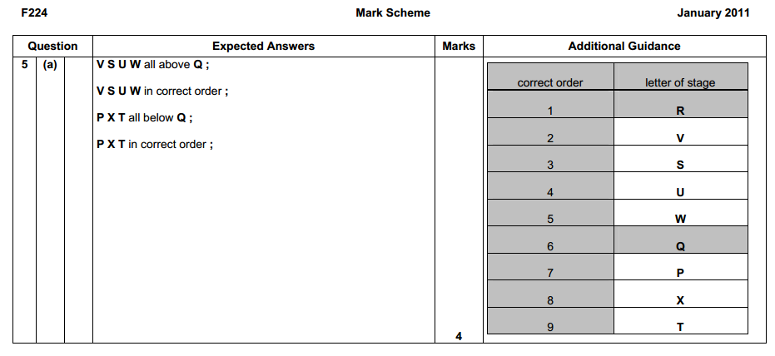

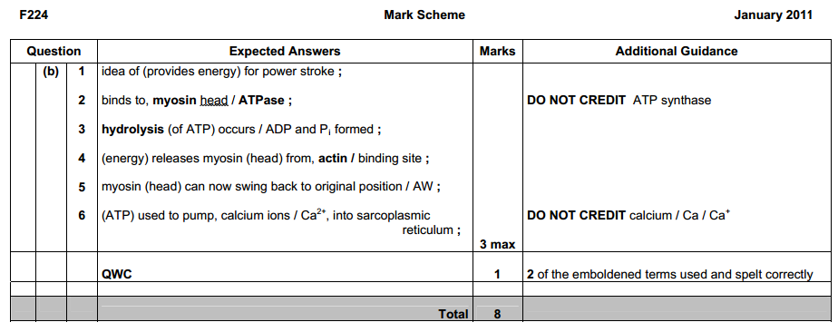

Mark Scheme June 2005 Question |  |  |  | Expected Answers | Marks
4 | (a) |  | (i) | A matrix ;  B crista ;  C ribosome ; |  |  | 3
(ii) |  | 46 / 47 / 48 x 1000 / 4.6 / 4.7 / 4.8 x 10 000 ;  50 000  0.92 / 0.94 / 0.96 (μm) ; A 920 / 940 / 960 nm  correct answer only ; ;  ecf ; wrong measurement correct method max 1 |  |  |  | 2
(b) |  | D inter-membrane space, (between two membranes) ;  H⁺ ions pumped into it / through ;  inner membrane impermeable to H⁺ ions ;  allows for the build up of H⁺ ions (in this area) ;  to build up, a concentration / an electrochemical gradient ;  to provide energy for ATP production / oxidative phosphorylation ;  AVP ; e.g. 3 H⁺ : 1 ATP (A for D or E) 3 max  E (channel in) the stalked particle ;  allows for the H⁺ ions to diffuse down the concentration gradient ;  H⁺ ions move through the channel ;  causes, ATP synthetase / ATP synthase / ATPase ;  to produce ATP from ADP + P_{i} ;  from, electrochemical / potential, energy ;  AVP ; e.g. chemiosmosis, detail on the action of the enzyme  3 max |  |  |  | 5 max
(c) |  | oxygen is the terminal, [H⁺] / proton / electron, acceptor ;  forms water ;  from H⁺ and e⁻ ;  2[H] + 2e⁻ + ½ O₂ = H₂O / 4H⁺ + 4e⁻ + O₂ = 2 H₂O ; |  |  |  | 2 max
