Homeostasis web quest
Use the web links below to find the answer to the questions and to help you complete the activities. DO NOT use any other websites! The sources have to be credible.
Write or type out your answers in your own words – do not copy and paste. If caught you will be asked to log off and use a textbook.
Web link 1 – click here
Web link 2 – click here
- What is homeostasis?

- Give three examples of homeostatic mechanisms in the body


Go to BBC Bitesize and read about how the body responds to hot and cold. Use this information to answer the questions below:

- Use the information on BBC bitesize to help you label the diagram below:
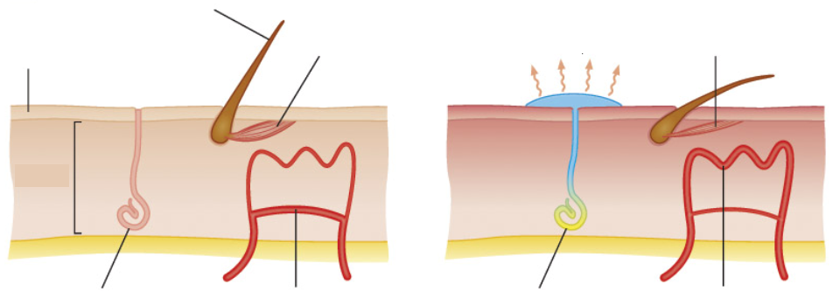

- Look carefully at the diagram below. Decide whether the response is to cold temperature or hot temperature and describe what is happening at points 1, 2 and 3.

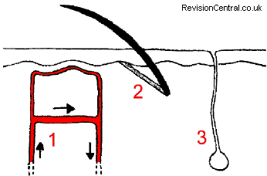

4. What does vasoconstriction mean? How is this helpful when you are trying to keep warm?

5. Look carefully at the diagram below. Decide whether the response is to cold temperature or hot temperature and describe what is happening at points 1, 2 and 3.
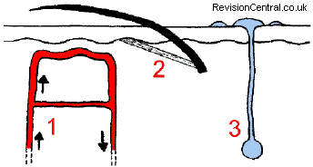

6. What does vasodilation mean? How is this helpful when you are trying to keep warm?

7. What part of your brain detects changes in body temperature? Insert a labelled diagram to help illustrate your answer.

Check that all your answers are correct. Print out this sheet with your answers on and stick it into your notes.

