No transcription at P (promoter region) means no translation and therefore no enzymes at Z or Y.
Repressor protein is partly blocking the promoter region (the section of DNA that codes for beta galactosidase and lactose permease.
When lactose is absent
NO enzymes are synthesised because they are not needed.
- The regulator gene regulates the production of these enzymes by making a repressor protein.

- The repressor protein blocks the control site at the operator gene to stop any protein synthesis that would lead to enzyme manufacture (remember, no lactose, no point!)

- RNA polymerase cannot get into the control site to start transcribing mRNA since the repressor protein is there blocking its path.

- Beta galactosidase and lactose permease cannot be made as a result

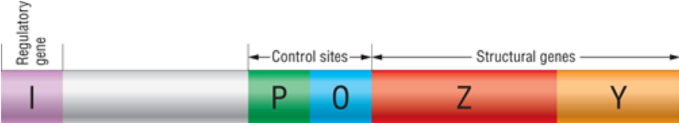

When lactose is present
Enzymes ARE synthesised because are needed to break down lactose into glucose and galactose.
- The regulator gene regulates the production of these enzymes by NOT making a repressor protein.

- When lactose is present, the repressor molecule does not get to bind with the control sites. It ends up binding to lactose.

- Lactose changes the conformation of the repressor protein, so it cannot bind to the operator (remember the operator is like an on/off switch for making enzymes)

- Because lactose has bound itself to the repressor protein, the promoter region is free to transcribe DNA into mRNA

- The mRNA that is transcribed is the information to make beta galactosidase and lactose permease

