Harris City Academy Crystal Palace



A2 Human Biology
(OCR)

MARK SCHEME

Human Biology Homework Booklet 4 (Year 13)



Contents page

F225 Module 2

Learning Package 1……………………………..………...…The nervous system 1 / How the eye works

Learning Package 2 …………………………………………………… The brain / The nervous system 2

Learning Package 3…………………………...………… Transmission of an action potential/ Synapses

Learning Package 4…...… Damage to the nervous system / Treating central nervous system injuries

Learning Package 5……….………………………….…………..….…… Modifying brain functions 1 & 2

Progress tracker
Week | Topic | Date | Target | Attainment  Grade | Attainment  Mark | Effort | Comm | Study Support
1 | The nervous system 1 / How the eye works |  |  |  | /33
2 | The brain / The nervous system 2 |  |  |  | /26
3 | Transmission of an action potential / Synapses |  |  |  | /33
4 | Damage to the nervous system / Treating CNS injuries |  |  |  | /23
5 | Modifying brain functions 1 & 2 |  |  |  | /41

Harris City Academy Crystal Palace

Human Biology
Unit F225

Weekly Learning Package – week 1
Year: | 13
Module: | Module 2 – The Nervous System
Outcomes: | - outline the organisation of the central nervous system and peripheral nervous system;  - describe, with the aid of diagrams and photographs, the structure of the eye and outline the functions of its parts;  - describe, with the aid of diagrams and electronmicrographs, the structure of the retina (including rods, cones, bipolar cells and ganglion cells);  - describe, with the aid of diagrams, how a sensory receptor converts a stimulus into nerve impulses with reference to the rod cell in the retina;  - outline assessment of receptor activity through routine eye tests (with reference to visual acuity, colour vision and response of pupil);  - outline the use of blink/iris reflex tests to indicate levels of consciousness.

Task | Completed
- Read pages 216 - 219  - Complete questions and evaluation at the end  - Use textbook and other resources to help you answer all questions to the best of your ability  - Listen to a science related podcast that captures your interest from http://www.theguardian.com/science/series/science | YES/NO  YES/NO  YES/NO

DUE:  Teacher Comment :  Student Comment : | HANDED IN:  YES/NO
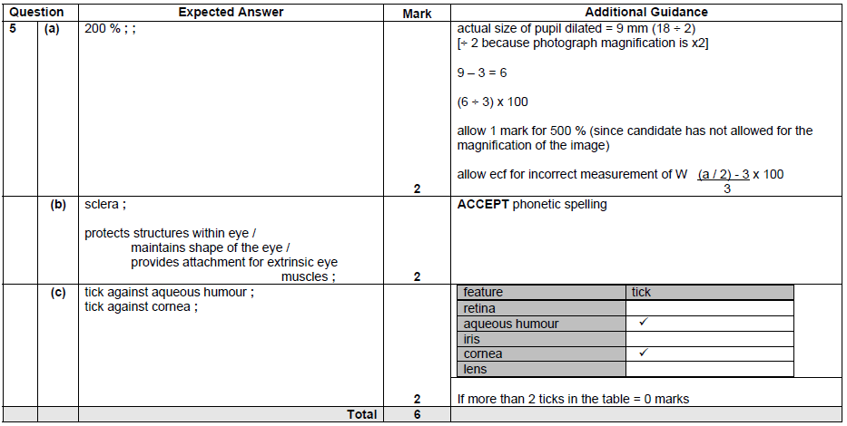
1.

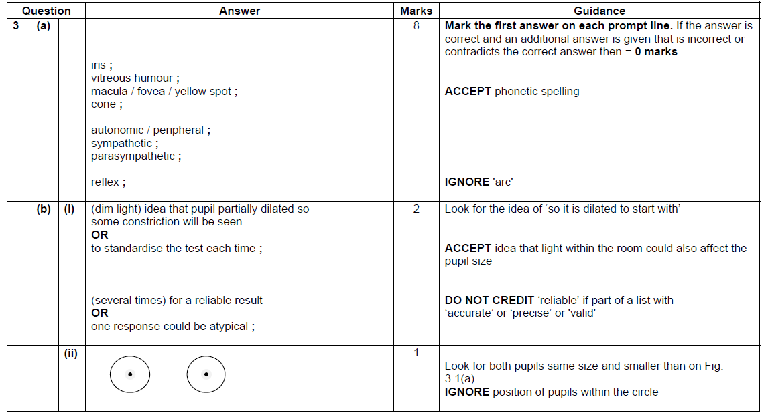
2.

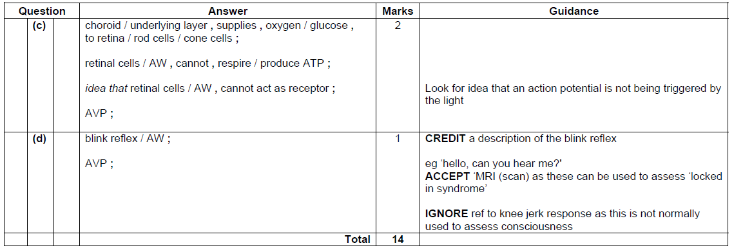

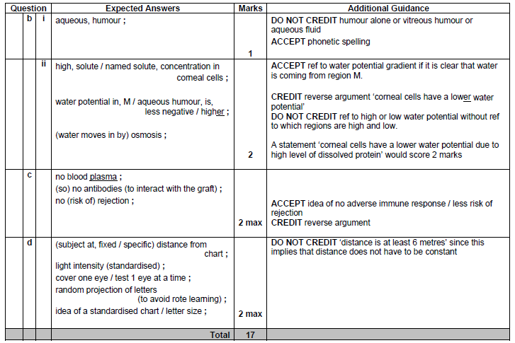
3.

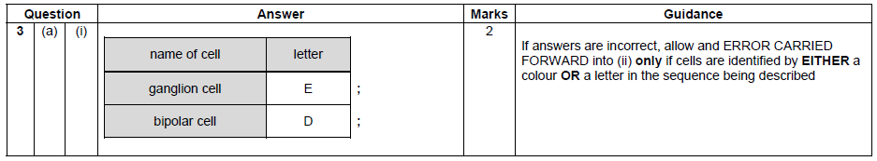
4.

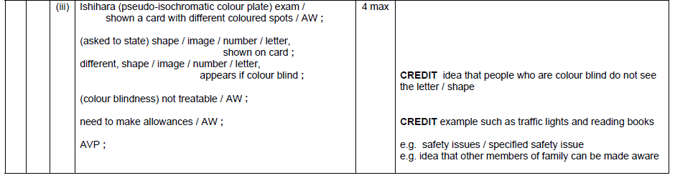

Harris City Academy Crystal Palace
Human Biology
Unit F225

Weekly Learning Package – week 2
Student name:
Year: | 13
Module: | Module 2 – The Nervous System
Outcomes: | - describe, with the aid of diagrams, photographs and images from MRI and CT scans, the gross structure of the human brain;  - outline the functions of the cerebrum, cerebellum and medulla oblongata;  - outline the organisation of the autonomic nervous system into a sympathetic and a parasympathetic system;  - describe, with the aid of diagrams, photographs and electron micrographs, the structure of a sensory neurone, a relay neurone and a motor neurone and outline their functions in a reflex arc;

Task | Completed
- Read pages 220 - 223  - Complete questions and evaluation at the end  - Use textbook and other resources to help you answer all questions to the best of your ability  - Listen to a science related podcast that captures your interest from http://www.theguardian.com/science/series/science | YES/NO  YES/NO  YES/NO

DUE:  Teacher Comment :  Student Comment : | HANDED IN:  YES/NO
1.
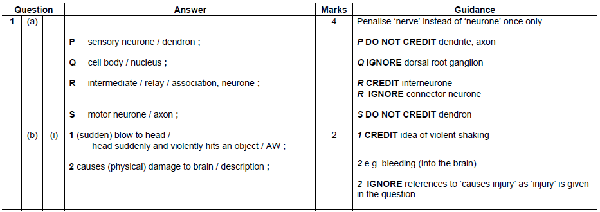

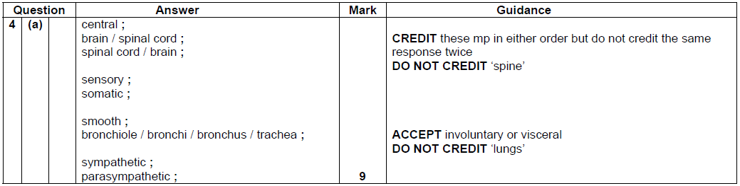
2.

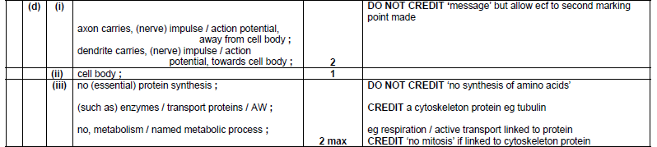

Harris City Academy Crystal Palace
Human Biology
Unit F225

Weekly Learning Package – week 3
Student name:
Year: | 13
Module: | Module 2 – The Nervous System
Outcomes: | - describe and explain, with the aid of diagrams, the transmission of an action potential in a myelinated neurone;  - explain the importance of saltatory conduction and the refractory period in the transmission of nerve impulses;  - describe, with the aid of diagrams and electronmicrographs, the structure and function of a cholinergic synapse;  - outline the role of synapses with reference to the direction of the nerve impulse and the interconnection of nerve pathways;

Task | Completed
- Read pages 224 - 227  - Complete questions and evaluation at the end  - Use textbook and other resources to help you answer all questions to the best of your ability  - Listen to a science related podcast that captures your interest from http://www.theguardian.com/science/series/science | YES/NO  YES/NO  YES/NO

DUE:  Teacher Comment :  Student Comment : | HANDED IN:  YES/NO

1
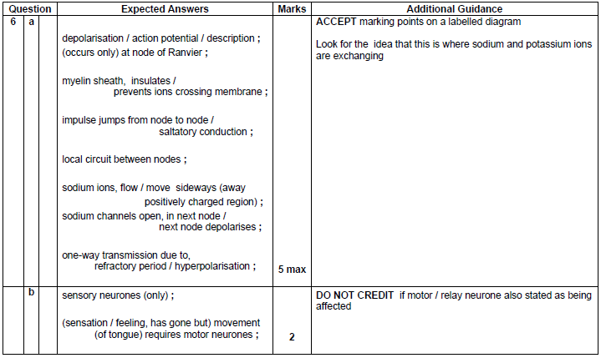

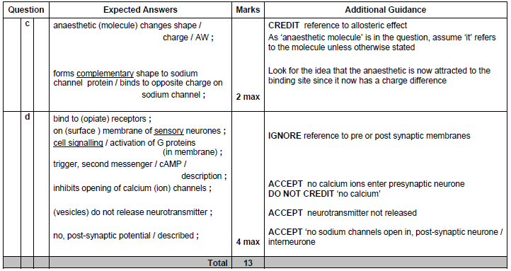

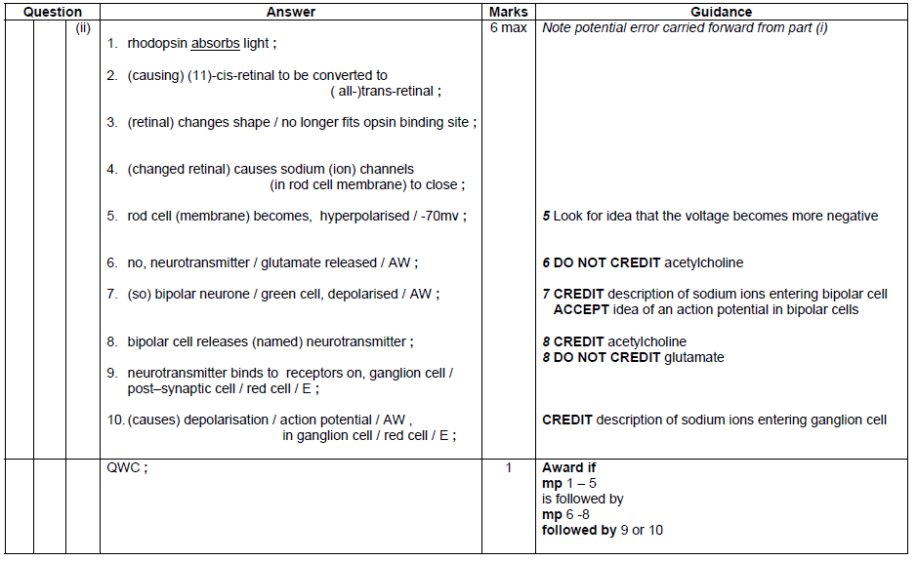
2.

3.
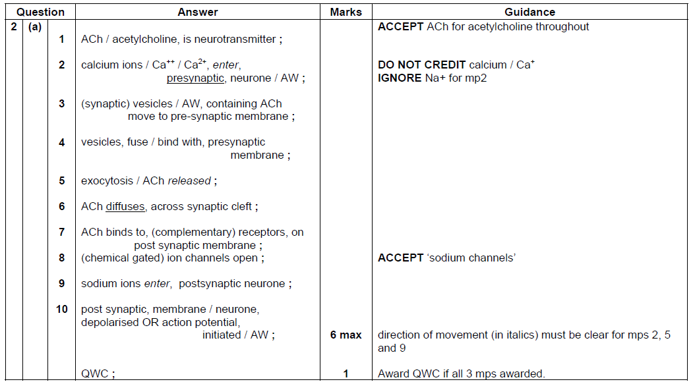

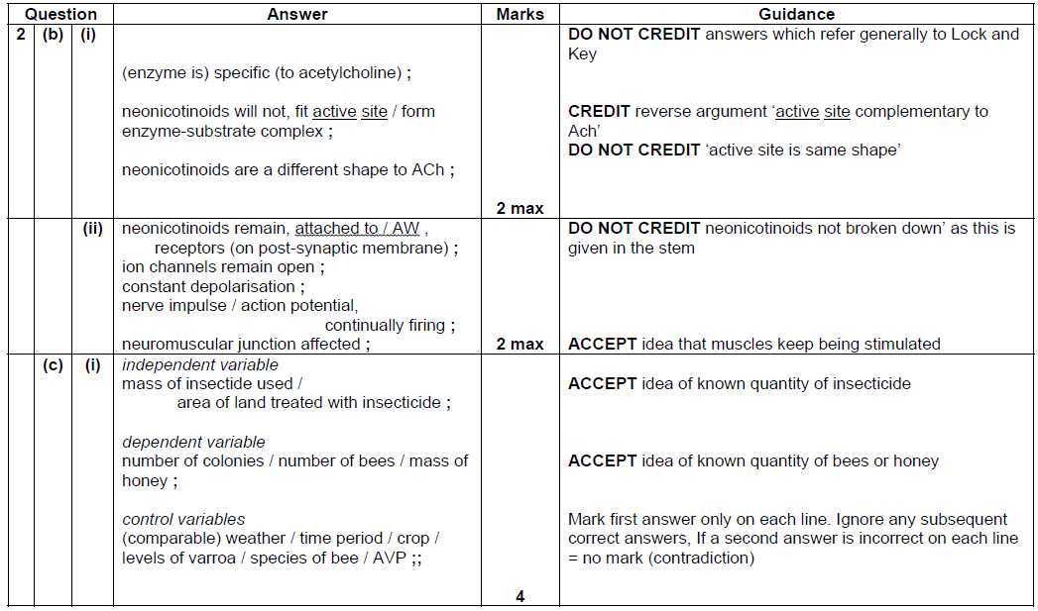

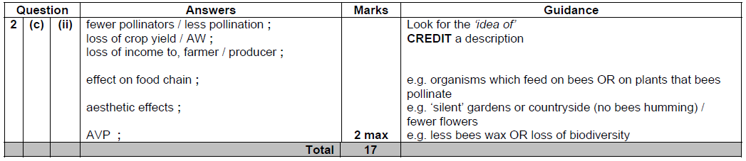

Harris City Academy Crystal Palace
Human Biology
Unit F225

Weekly Learning Package – week 4
Year: | 13
Module: | Module 2 – The Nervous System
Outcomes: | - define the term traumatic brain injury;  - outline how CT and MRI scans and nerve conduction velocity tests can be used in the assessment of brain and spinal cord damage (HSW7b);  - explain why damaged neurones are unable to regenerate (reference should be made to inhibitory molecules in scar tissue and poor regenerative response);  - explain the potential use of stem cells to replace lost or damaged neurones (HSW6a, 7b);  - describe the effects of strokes on short- and long-term memory (HSW6b, 7c);  - describe the techniques that may be used to improve memory in stroke patients (HSW6b).

Task | Completed
- Read pages 228 - 231  - Complete questions and evaluation at the end  - Use textbook and other resources to help you answer all questions to the best of your ability  - Listen to a science related podcast that captures your interest from http://www.theguardian.com/science/series/science | YES/NO  YES/NO  YES/NO

DUE:  Teacher Comment :  Student Comment : | HANDED IN:  YES/NO
1
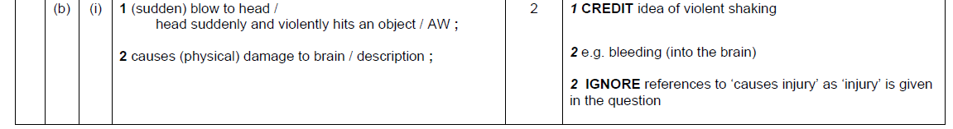

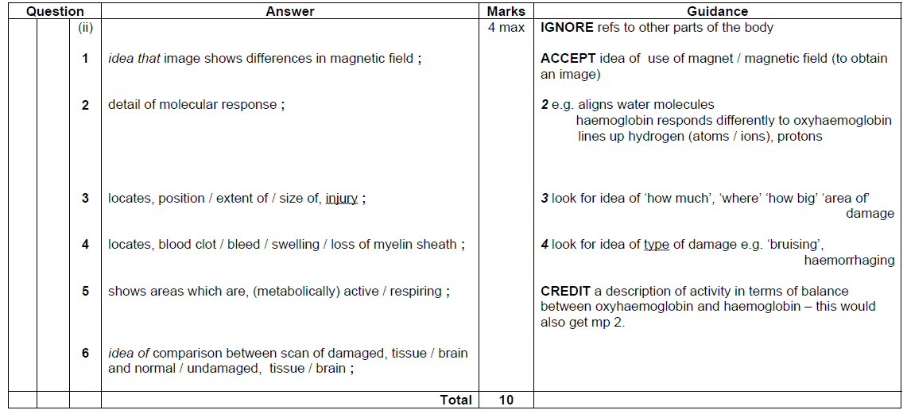

2.
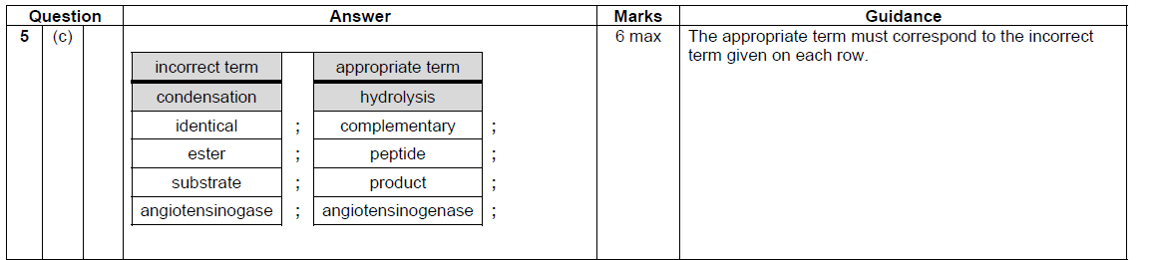
3.
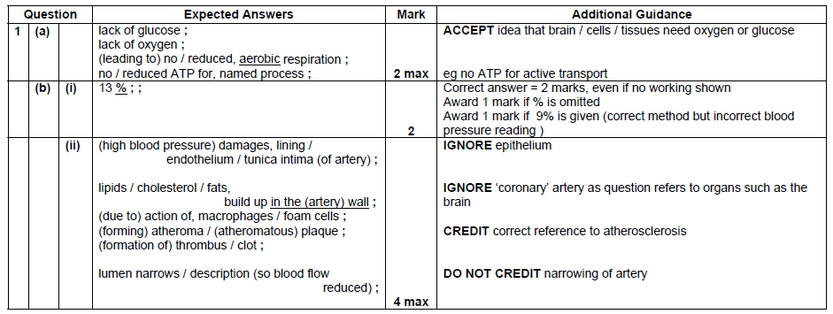

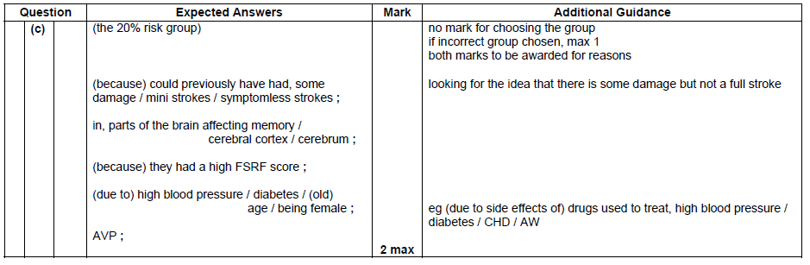

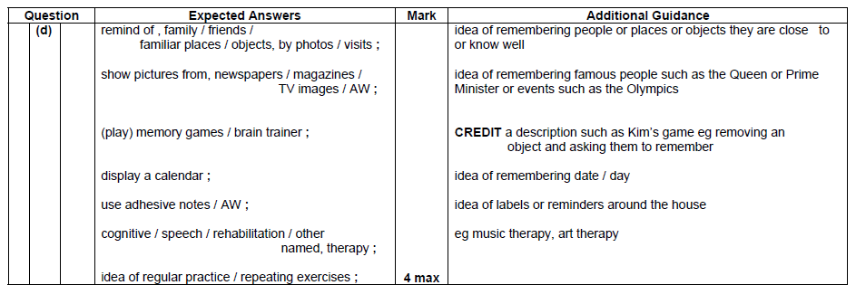

Harris City Academy Crystal Palace
Human Biology
Unit F225

Weekly Learning Package – week 5
Year: | 13
Module: | Module 2 – The Nervous System
Outcomes: | - define the term drug, with reference to both therapeutic and abusive aspects (HSW6a, 7c);  - describe how drugs can be used to modify brain activity and function, with reference to dopamine for the treatment of Parkinson’s disease and diamorphine (heroin) for the relief of severe pain (HSW6b);  - outline how opioids mimic the effects of naturally occurring endorphins, with reference to blocking the transmission of pain;  - discuss the use of cannabis, both therapeutically and recreationally (HSW6a, 7a, 7b, 7c);  - distinguish between psychological and physical dependency, with reference to heroin and alcohol.

Task | Completed
- Read pages 232 - 235  - Complete questions and evaluation at the end  - Use textbook and other resources to help you answer all questions to the best of your ability  - Listen to a science related podcast that captures your interest from http://www.theguardian.com/science/series/science | YES/NO  YES/NO  YES/NO

DUE:  Teacher Comment :  Student Comment : | HANDED IN:  YES/NO

1.
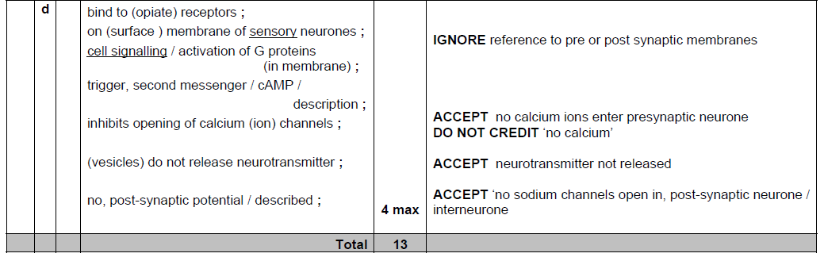

2.
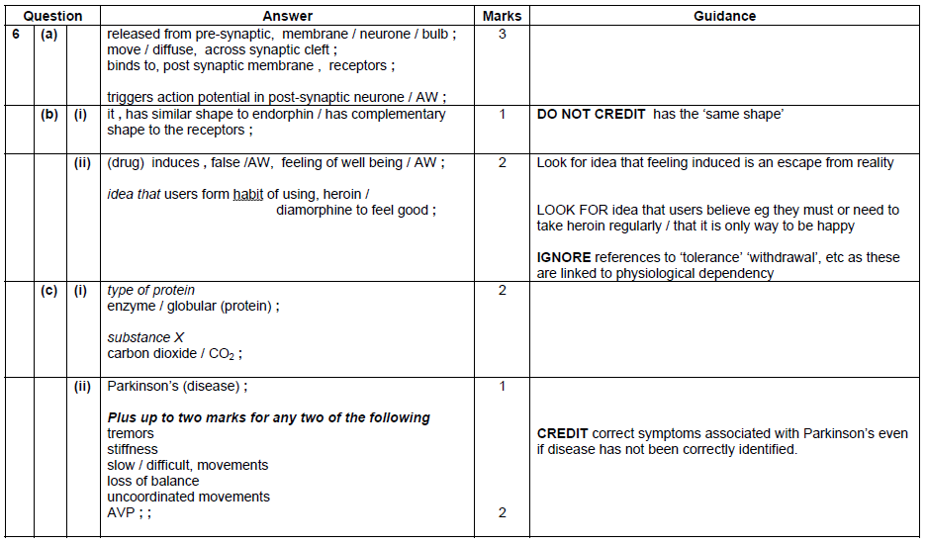

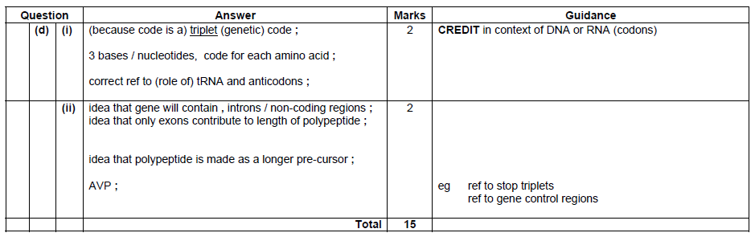

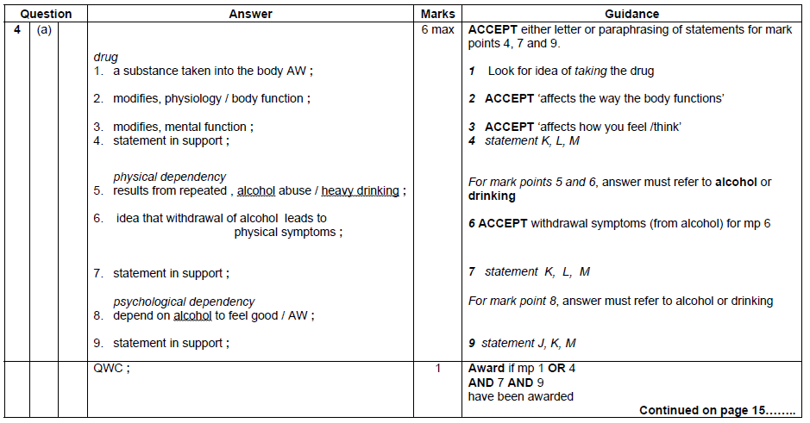
3.

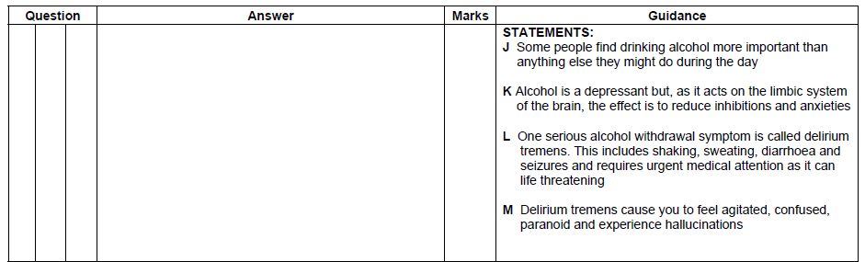

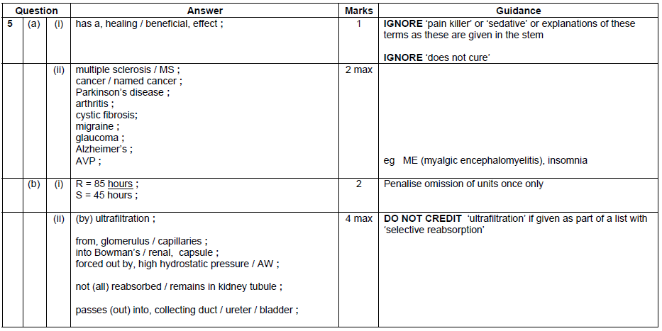
4.

