“Describe the process of DNA replication.” (8)

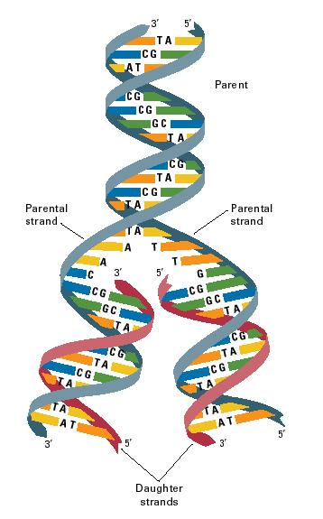
DNA replication is described as semi-conservative. This is because only one side of the DNA strand is used to make the complementary strand. At the end of DNA replication, two daughter strands are produced, each having a newly synthesised strand, as well as one original strand.

The first stage of DNA replication is the unwinding of the double helix to leave two parallel strands of DNA. Hydrogen bonds break between complementary bases, causing the DNA to unzip. Each of the newly exposed single DNA strands act as a template to synthesis a complementary DNA strand. This is done by free nucleotides pairing up with their complementary base partner.
The base adenine pairs up with thymine, while guanine pairs up with cytosine. Two hydrogen bonds form between adenine and thymine, and three hydrogen bonds form between guanine and cytosine.
As adjacent nucleotides bond with their complementary base, a strong covalent bond forms between the pentose sugar of one nucleotide and the phosphate of another. Forming this phosphodiester bond is controlled by the enzyme DNA polymerase.

