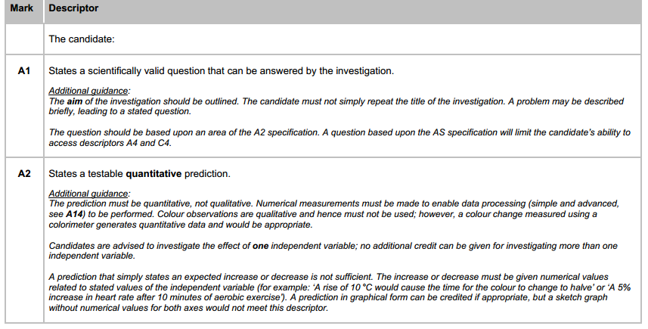
Investigations can be similar to each other, as long as they’re different in some way and you do all the work yourself, it counts as a novel investigation.
Some ideas you might want to consider:
- How environmental stresses affect the ability to perform tasks / memorise information / ?
- Does eating breakfast affect reaction rate?
- Does cardiovascular exercise improve memory?
- Does cardiovascular exercise improve problem solving ability?
- Does gender affect the ability to recover quickly after dynamic/static exercise?
- How does age / gender affect short term/long term memory?

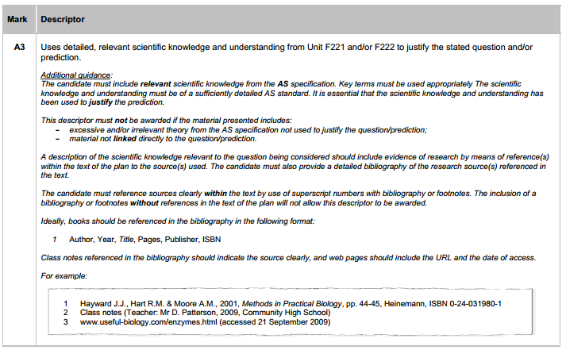
OK so this means that you have to go back through the first half of the textbook and find the pages that link to your investigation. If you’re looking at gender and exercise, maybe human growth pattern and stuff on heart and lungs would be of interest.
Most investigations relating to any physiological activity will involve the heart/lungs. Just make sure you can say why!!!

Once you’ve done that, look for evidence from research to back up what you’re saying. It’s essential that sources are credible and that you understand what they are on about! Ask the librarians for help – they’re great at this stuff.

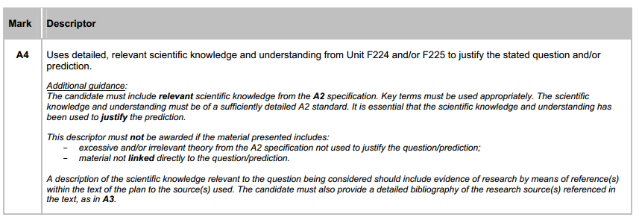
Do what it says!

