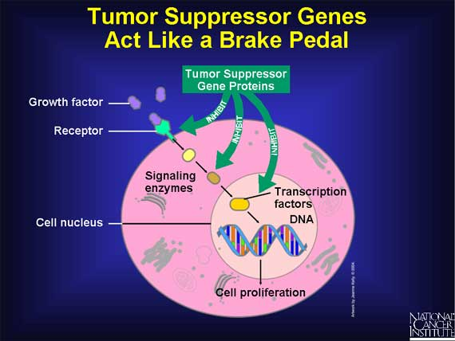
Tumour suppressor genes code for protein that control the cell cycle. One of these proteins is called p53. The job of the p53 protein is to stop mitosis when it should not happen. This can be for a number of reasons:
- The DNA is damaged and needs to be repaired before anything else can happen
- The DNA is damaged and needs to undergo apoptosis

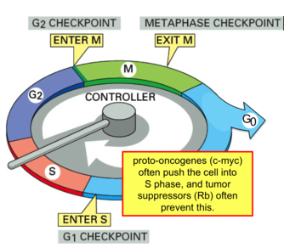
Proto-oncogenes and Oncogenes
Proto-oncogenes help to regulate cell division during the cell cycle. They can be switched on or off by chemicals in the body such as growth factors or hormones.
When proto-oncogenes are activated, they will cause cells to move into the synthesis (S) phase of cell cycle – this means the cell has to divide.
Mutated proto-oncogenes become oncogenes. In this state, they are permanently switched on and will keep going through the cell cycle without stopping at any check points.
Unregulated cell cycle means that mitosis occurs at a much faster rate, resulting in the development of tumours.

