Diary of a Dog

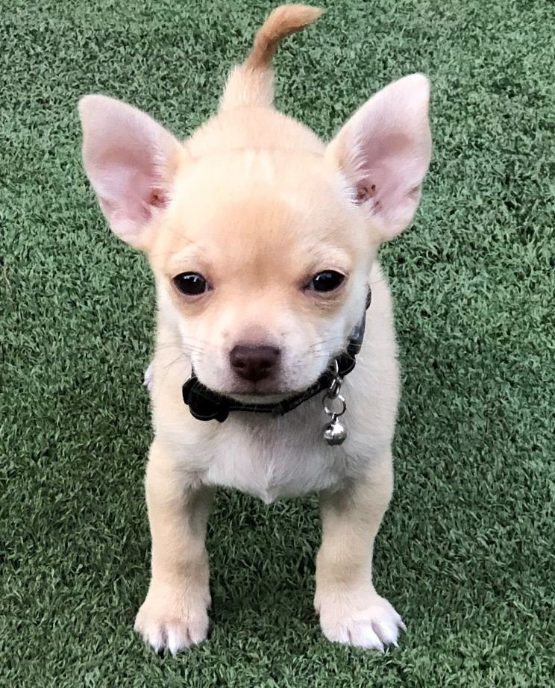

Logging Neo’s Development

This logbook belongs to ______________

This logbook is for you to keep a scientific diary of Neo the chihuahua’s progress from being a puppy to an adult dog.
Neo is a dog breed from Mexico. Use the internet to find three facts about chihuahuas and write them down in the space below.
_______________________________________________
_______________________________________________
_______________________________________________
_______________________________________________

Draw a picture of Neo in the space below.

Read the information below carefully.
When Neo was 7 weeks old, she weighed 800g. She was so small that she could fit in her owner’s hand, which was 18cm long from her to the top of her middle finger.
A week later, the vet weighed Neo again and she was 980g and was 20cm in length.

Questions
- How much did Neo weigh when she was 7 weeks old?

___________ grams

- How much did Neo weigh when she was 8 weeks old?

___________ grams

- How much weight had Neo put on in one week? Show all your working.

Activity – draw around your hand and measure the distance from the top of your middle finger to the base of your hand. Would Neo fit in your hand?

Challenge questions
- Can you convert your answer in cm to mm? __________________
- How much longer is Neo than your hand? ___________________
- Can you find another household object that is the same length as your hand? Write down at least one thing. ________________________
Now that Neo is 11 weeks old, she is 1200g and eats a lot! She also has much more energy and likes to play.
Neo’s owners would like to know how much Neo eats during the day when they are at work. They also want to know which toys are her favourites.
It is your job as a scientist to observe (watch) Neo and take measurements!

Colour in the picture of the scientist!
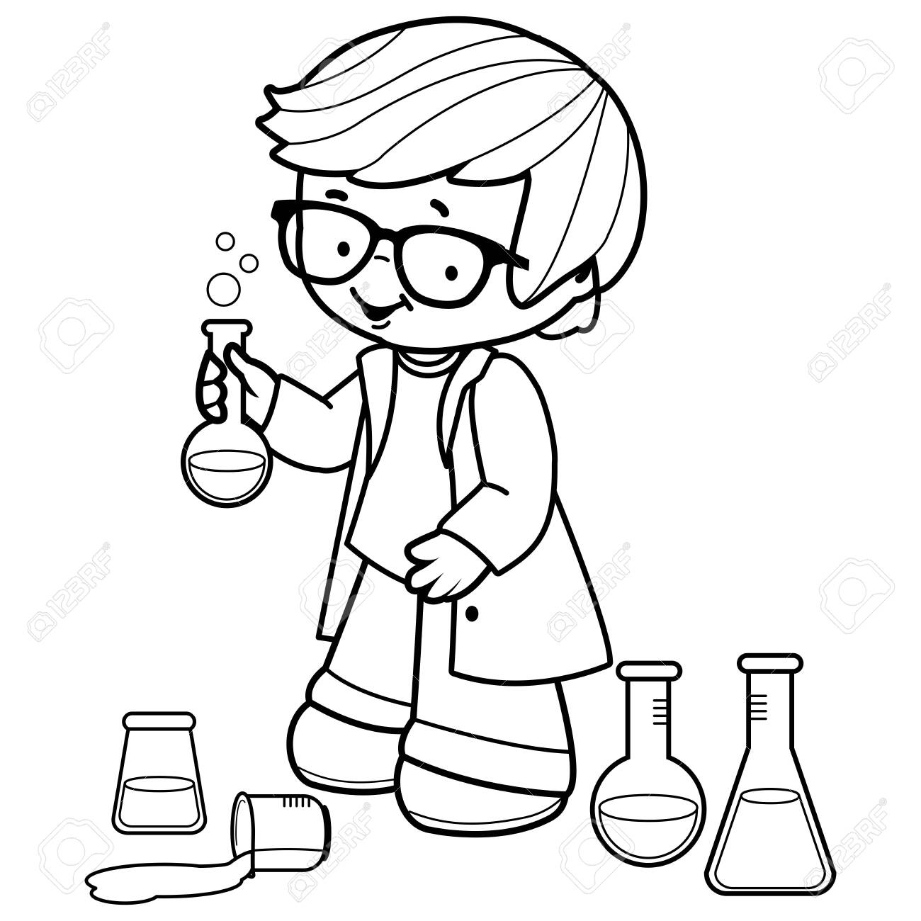

Experiment 1 – Finding how much Neo eats in a day
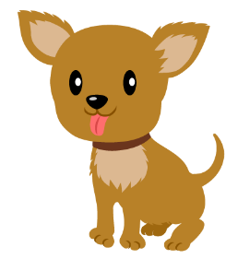
ALWAYS WASH YOUR HANDS BEFORE AND AFTER HANDLING ANIMALS
Neo is a puppy and so needs lots of food, however, because she is a chihuahua, she does not need to eat very much in one meal.

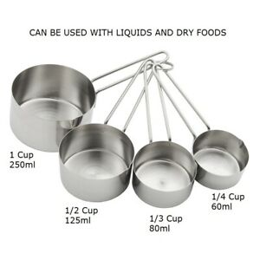
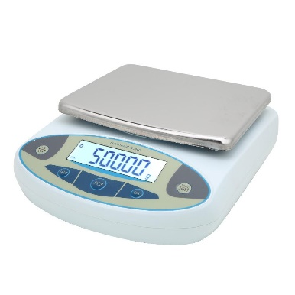
The aim of this experiment is to find out how much food Neo eats in a day.

Equipment that you will need:
- dog biscuits
- digital balance
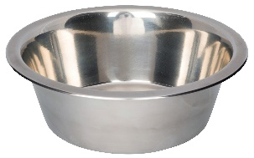
- Neo’s dog bowl
- measuring cup

Method (how you will do the experiment)
- Collect the dog biscuits and a measuring cup
- Fill up the measuring cup half way with the dog biscuits
- Put the cup with the dog biscuits on the digital balance and find out how much it weighs
- Put the biscuits in Neo’s bowl
- Put the empty cup back on the balance and find out how much that weighs. Challenge: why do we need to do this?
- Write down your results in the table on the next page.

Today is __________________ The date is _________________

How much Neo eats in one day
Time of day food was given | Mass of cup and food (g) | Mass of cup on its own (g) | Mass of food (g)
Total mass of food

Measuring the “weight” of something tells you how heavy it is. In science, we call weight “mass”. This is a better term to use.
Questions:
- What are the units of mass that we have used to measure Neo’s food? ____________________________

- How many grams are there in a kilogram? ________________

- If Neo’s mass is 1200 grams, how many kilograms are in 1200 grams? _________________

- If there were 5 Neos, what would be the total mass of all the dogs together?

- Use the information in your table to find how much food Neo ate today.
Show your working out.

- What time of day did Neo eat the most food? _____________

- Draw a picture of the time on a clockface in the space below.

- Challenge question – what was the time in 24-hour clock?

_______________

Graphing your results
Use the information that you collected from your data table on page 7 to draw a bar graph of how much food Neo ate at different times of day. You must draw your graph with a pencil and a ruler.
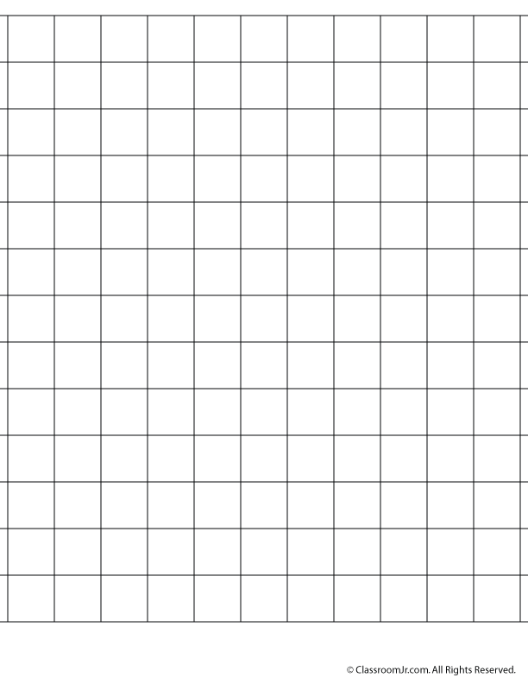
Time of day food was given
mass of food (g)
Conclusion
A conclusion is where you look at what you found out from your experiment and write down a sentence or two to tell the reader about your results.
_______________________________________________
_______________________________________________
_______________________________________________
_______________________________________________

Experiment 2 – Finding how long Neo sleeps during the day
ALWAYS WASH YOUR HANDS BEFORE AND AFTER HANDLING ANIMALS
Puppies are just like babies and toddlers – they need lots of sleep to help them grow and get stronger. Sleep is very important in helping our bodies to heal, get strong and be well.

The aim of this experiment is to find out how long Neo sleeps.
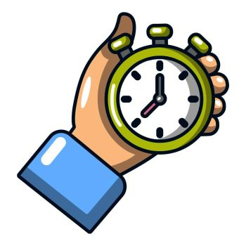
Equipment that you will need:
- a pencil
- a stopwatch / similar timer device

Method (how you will do the experiment)
- Observe Neo throughout the day and note down the times that she goes to sleep

- When you notice that she is sleeping, start your stopwatch

- Do not disturb her while she is sleeping, but quietly and carefully check on her from time to time to check that she is still sleeping

- When she wakes up, stop your stopwatch and write down the time in your table (on the next page)
Today is __________________ The date is _________________

How long Neo naps for in a day
Naps | Time spent napping (minutes)
1
2
3

Experiment 3 – Neo’s Favourite Toy
ALWAYS WASH YOUR HANDS BEFORE AND AFTER HANDLING ANIMALS

An important part of science is observation. This is when the scientist (that’s you!) watches carefully and writes down what they find out.
Observing animals without influencing their behaviour tell you a lot about what they like and dislike.
Why do you think this is important?
___________________________________________________________
___________________________________________________________

Your task
Pick a day when you are not doing experiment 1 or 2 to collect information on Neo’s favourite toy.
Write down the toys that Neo has to play with that day in the table below and note down how many times she plays with that toy as tally marks.
Neo loves to share her toys, so make sure you play with her!

The first row in the table is an example
Toy | Number of times played with
Stick | 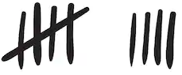

Conclusion
What did you find out from your observations?
Which toy was Neo’s favourite and how did you know?
___________________________________________________________
___________________________________________________________

Which toy was Neo’s least favourite and how did you know?
___________________________________________________________
___________________________________________________________

Draw a picture of Neo’s favourite toy.

Design Activity
Neo needs a new collar and coat for when she goes to the park in winter when it is cold.
- Design her a dog collar in the space below.

- Design a coat for Neo. Find pictures on the internet to help you come up with some ideas.

Report time
Make an information poster or powerpoint to summarise what you found out about Neo.
Your poster or powerpoint should have:
- Information about Chihuahuas that you researched at the start
- A paragraph to summarise experiment 1
- A paragraph to summarise experiment 2
- A paragraph to summarise experiment 3
- At least 2 pictures of Neo – these can be photographs or your own drawings
Once you have made your poster, you must present your findings. You can record a video of yourself presenting your report, or you can FaceTime someone and present to them live!
